**Lesson 4-See who is faster**

****1.Learning goals:****

This lesson learns to how to complete a fruit game with this alligator clip expansion board.

****2.Search for blocks:****

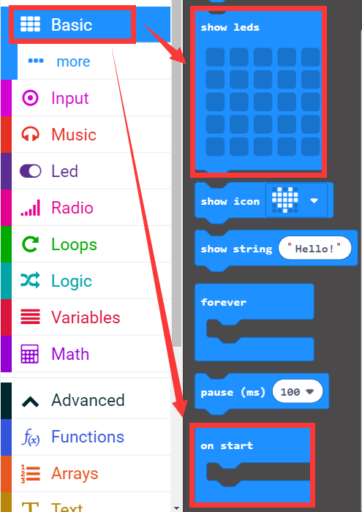

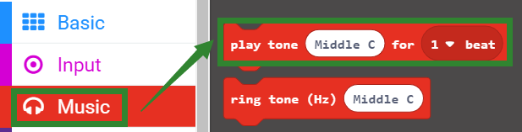

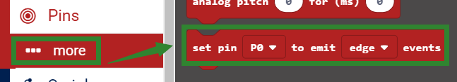

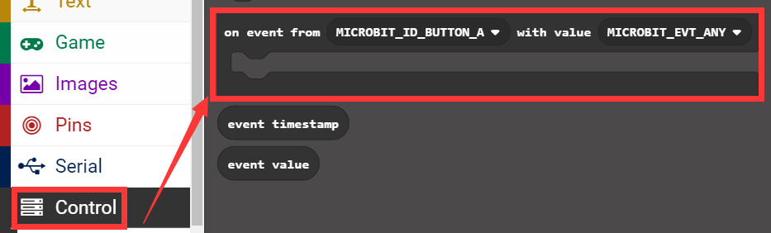

****3.Combine blocks:****

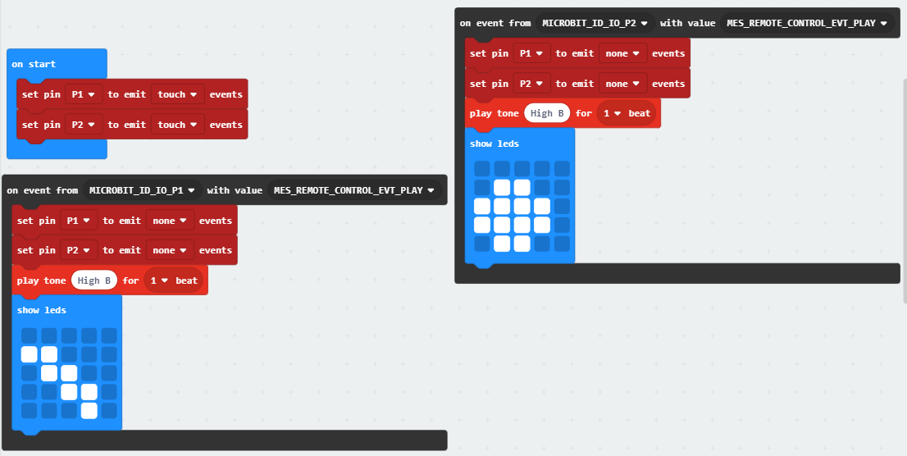

**4.Download programming**

After the program is downloaded.

First, we need to use one end of the alligator clip to clamp a fruit(such as banana) and the other end to the P1 of the micro:bit gold finger.

Then, we need to use one end of the alligator clip to clamp another fruit(such as pear) and the other end to the P2 of the micro:bit gold finger.

Next, we need to use one end of the alligator clip to clamp GND of the micro:bit gold finger and the other end need to be held by one person (partner A).

Finally, we need to use one end of the alligator clip to clamp GND of the micro:bit gold finger and the other end need to be held by another person (partner B).

As shown in the figure below.

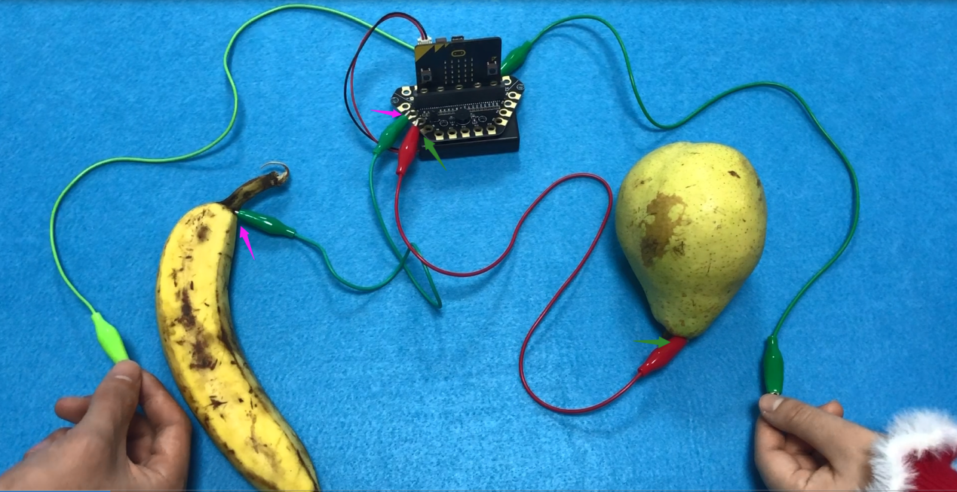

In this experiment, whoever touches the fruit first, the pattern of the fruit is displayed on the dot matrix. As shown in the figure below.

